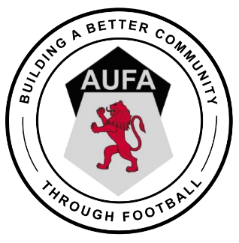 | Wellbeing Wheel

Best start in life, ready to succeed as successful learners, confident individuals, responsible citizens and effective contributors.
Supported to be:

Achieving
Being supported and guided in learning and in the development of skills, confidence and self-esteem, at home, in school and in the community.

Nurtured
Growing, developing and being cared for in an environment which provides the physical and emotional security, compassion and warmth necessary for healthy growth and to develop resilience and a positive identity.

Active
Having opportunities to take part in activities such as play, recreation and sport, which contribute to healthy growth and development, at home, in school and in the community.

Respected
Being involved in and having their voices heard in decisions that affect their life, with support where appropriate.

Healthy
Having the highest attainable standards of physical and mental health, access to suitable healthcare, and support in learning to make healthy and safe choices.

Safe
Growing up in an environment where a child or young person feels secure, nurtured, listened to and enabled to develop to their full potential. This includes freedom from abuse or neglect.

Included
Having help to overcome inequalities and being accepted as part of their family, school and community.

Responsible
Having opportunities and encouragement to play active and responsible roles at home, in school and in the community, and where necessary, having appropriate guidance and supervision.

